Five lessons from India’s education DIBs
By Anushree Parekh, Rhea Miranda: August 11, 2023

India has made significant progress in achieving universal primary school enrolment, with a gross enrolment ratio (GER) of 100 percent. However, most students still lack basic learning skills. Only 43 percent school students in grade 5 can read a grade 2 level text, and only 26 percent of these students can do division. Foundational literacy and numeracy (FLN) form the basis of all future learning and affects life outcomes. High rates of FLN are directly correlated to increased workforce participation and higher per capita gross domestic product (GDP).
Both the public and private sectors have invested in improving the quality of foundational learning in schools, and India has emerged as a sandbox for innovations in financing models for education with grants, debt-based models, impact bonds, and other instruments. With all three impact bonds now completed, it is an opportune time to reflect on them and distil early lessons for the primary education sector in India. These learnings offer an insight into how programmes can be designed and delivered more effectively to improve the quality of learning for India’s children.
- Donors can link funding to improvements in learning outcomes, rather than only to inputs or activities: The focus of the three education impact bonds was on improving learning among children. Accordingly, they measured and tied funding to learning outcomes as key success metrics.
- Both direct and indirect interventions can improve learning among children, with varying implications on depth and scale of impact: Education interventions can be broadly categorised as direct or indirect. In direct interventions, implementation partners work directly with children to deliver their inputs. In indirect interventions, they build the capacities of key stakeholders such as teachers, principals, and government officials to enable them to perform well, and therefore improve quality of learning.
- Targeted and structured collaboration between implementation partners can improve learning outcomes: The QEI DIB brought together the complementary expertise of two vastly different social organisations- an EdTech partner and a nonprofit- to deliver better learning outcomes for a common group of children.
- Providing flexibility to nonprofits to adapt, adopt, and innovate can yield high outcomes: A common learning for all three impact bonds has been around providing flexibility to implementation partners to adapt their interventions based on on-ground needs and realities. Along with the implementation partner’s expertise, intervention adaptations are guided by strong performance management systems and data-based decision-making.
- Building and sharing evidence on learning can lead to improved programme and evaluation design: Assessing learning outcomes remains a complex and nuanced process. It starts with defining the right metrics to capture learning skills and competencies across different age and grade groups, determining the period needed to realise these changes, and developing appropriate methodologies that allow for this testing.
These lessons from impact bonds in education stand to offer invaluable insights to donors who aim to improve the quality of learning among children. While it may not be possible, or even desirable, to replicate impact bonds to achieve these goals again, the learnings can be incorporated into grant-based or other financing mechanisms to ensure that development funds are able to achieve the outcomes they seek in an efficient and effective manner.
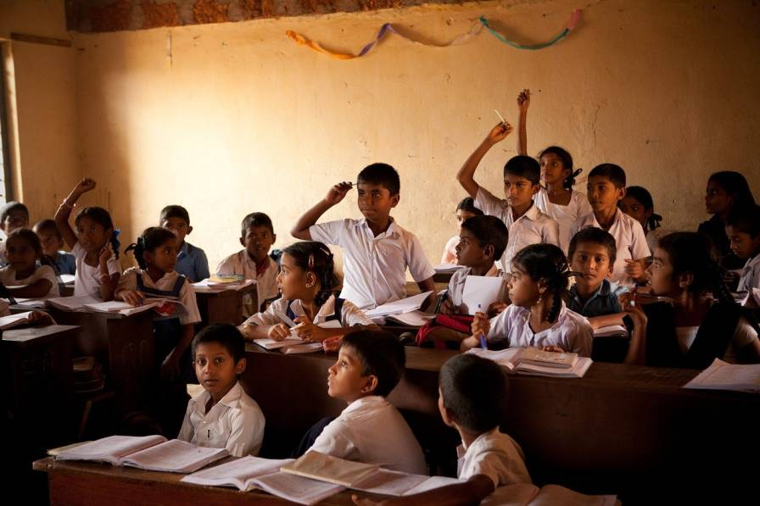

https://idronline.org/article/philanthropy-csr/5-lessons-from-indias-education-dibs/

